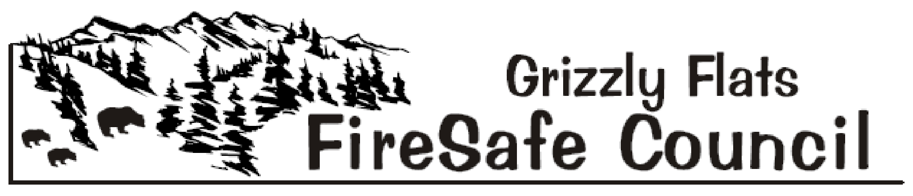
The Mission of the Grizzly Flats Fire Safe Council is to preserve Grizzly Flats’ natural and manmade resources by informing, educating and mobilizing all residents and landowners to make their homes, properties, neighborhoods and the community fire safe, and to provide area-wide cooperation, innovation and action in an effort to buffer the Grizzly Flats Fire Safe Council’s Sphere of Recognition from catastrophic wildfire
www.grizzlyflatsfsc.com

DRAFT Agenda – January 7, 2023, 9:30 a.m.
Meeting Location: Virtual - Zoom

- Call to Order

- Flag Salute

- Roll Call

- Timekeeper Volunteer

- Approval of the January 7, 2023 Agenda

- Approval of the November 5, 2022 Minutes

- Treasurer’s Report – Robin Kelley

- Public Comment – Limited to 3 minutes for items not already on the agenda.

- Council Member Comments – Limited to 3 minutes for items not already on the agenda.

- Agency Reports
- BOS District 2 Supervisor – George Turnboo
- Pioneer Fire Protection District – PFPD Chief Dave Whitt/Fire Marshal Ken Earle
- El Dorado County Department of Transportation – Dep. Director Maint. Brian Mullens
- Grizzly Flats Community Services District – District Manager Jodi Lauther
- El Dorado County Sheriff's Office / OES – Sheriff Jeff Leikauf
- El Dorado County Fire Safe Council – Ernie Lory
- California Highway Patrol – Public Information Officer Andrew Brown
- U.S. Forest Service – Placerville Dist. Ranger Scot Rogers
- CAL FIRE, Amador-El Dorado Unit –Battalion Chief Josh Vickers
- Neighboring Fire Safe Councils
- Aukum/Fairplay
- Omo Ranch
- Sand Ridge

- Long Term Recovery Group – Jennifer Hibbard

- Old Business
- GFFSC Vacancies – Mark Almer – Discussion/Action
- Time Sheet Submittal – David Manske – Discussion/Action

- New Business
- 2023 Meeting Dates – Mark Almer – Discussion / Action
- 2023 GFFSC Sponsored Events – Ernie Lory - Discussion / Action
- Routes Out of the Community Signage – Mark Almer - Discussion / Action
- BBQ Fundraiser / Firewise Event – Mark Almer – Discussion / Action

- Committee Reports
- Public Education - Mark Almer / Jennifer Hibbard
- Defensible Space – Robin Kelley / Liz Lawless / David Manske
- Grants – Ernie Lory / David Manske
- Fundraising – Robin Kelley / David Manske / Jennifer Hibbard
- Website – Jennifer Hibbard / Robin Kelley / David Manske

- Public Announcements

- For the Good of the Order

- Adjourn

