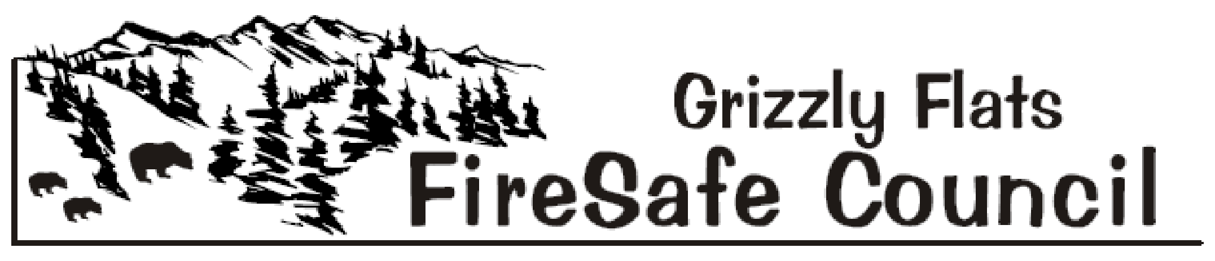
The Mission of the Grizzly Flats Fire Safe Council is to preserve Grizzly Flats’ natural and manmade resources by informing, educating and mobilizing all residents and landowners to make their homes, properties, neighborhoods and the community fire safe, and to provide area-wide cooperation, innovation and action in an effort to buffer the Grizzly Flats Fire Safe Council’s Sphere of Recognition from catastrophic wildfire

Agenda-October 3, 2020 9:30 a.m.- Telephone Meeting

1) Call to order

2) Flag Salute

3) Roll Call

4) Meeting Room Cleanup Volunteers & Timekeeper Volunteer

5) Approval of the October 3, 2020 Agenda

6) Approval of the September 12, 2020 Minutes

7) Treasurer’s Report- Robin Kelley

8) Public Comment
(Limited to 3 minutes - only for items not on the agenda)

9) Council Member’s Comments
(Limited to 3 minutes - only for items not on the agenda)

10) Agency Reports
- BOS Reports District 2 Supervisor. - Shiva Frentzen

- Pioneer Fire Protection District –Chief Mark Matthews/Battalion Chief Mike
Stutts

C. Department of Transportation (DOT) – Brian Mullens

D. Grizzly Flats Community Service District - Kim Gustafson

E. Sheriff – John D’Agostini/Jack Kerruish

F. El Dorado County Fire Safe Council - Ernie Lory

G. California Highway Patrol – Public Information Officer - Andrew Brown

H. USFS - District Ranger Scot Rogers/Rick Hopson

I Amador El Dorado Unit Cal Fire - Public Information Officer- Diana Swart

J. Neighboring Fire Safe Councils
- Aukum/Fairplay
- Omo Ranch
- Pleasant Valley

11) Old Business
- Emergency Evacuation Route Signage – Chief Matthews/Mike Stutts – Discussion/ Action Item

- GFFSC Vacancies – Mark Almer/Ernie Lory- Discussion/Action Item

- AT&T Phone Issues- Mark Almer/Kelly Krohn/Phill Dayton Discussion/Action Item

- Capps Crossing Road Issues- Mark Almer Discussion/Action

12) New Business
- Revised Fuel Reduction Project Priority List (Table B) – Mark Almer Discussion/Action Item

13) Committee Reports
- Public Outreach Coordinator – Deb Gregory

- Defensible Space - Steve Frasier/Robin Kelley

- Grants – Ernie Lory/Kelly Krohn/David Manske

- Public Education – Deb Gregory/Kelly Krohn/Molly Irish

- Fundraising- Kelly Krohn/Robin Kelley/David Manske

14) Public Announcements

15) For the Good of the Order

16) Adjourn

Regular Local Fire Safe Councils and District Meetings:

Grizzly Flats FSC - 1st Saturdays 9:30 AM, Telephone Meeting (Temporary)
Pioneer Fire Protection District - 2nd Tuesdays 6 PM, Station 38
Pleasant Valley FSC - 2nd Thursdays 7 PM - Pleasant Valley Community Hall
Aukum/Fairplay FSC- 3rd Wednesdays 7 PM - Pioneer Park Hall
Omo Ranch FSC - 4th Saturdays 9 AM – Indian Diggings School

