|  |
| --- |
| Mark Almer, Chairman  Ernie Lory, 1st Vice Chair  David Manske, 2nd Vice Chair  Deirdre Girardi, Secretary  Robin Kelley, Treasurer |

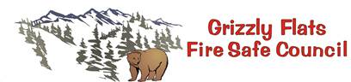

|  |
| --- |
| **P.O. Box 152, Grizzly Flats, CA 95636** |

__________________________________________________________________________________________

**2023 GFFSC Meeting Dates**

**January 7, 2023 (Zoom)**

**February 4, 2023 (Zoom)**

**March 4, 2023 (Zoom)**

**April 1, 2023**

**May 6, 2023**

**June 3, 2023**

**July 8, 2023 (note – second Saturday of the month due to holiday)**

**August 5, 2023**

**September 9, 2023 (note – second Saturday of the month due to holiday)**

**October 7, 2023**

**November 4, 2023**

**December – NO MEETING**