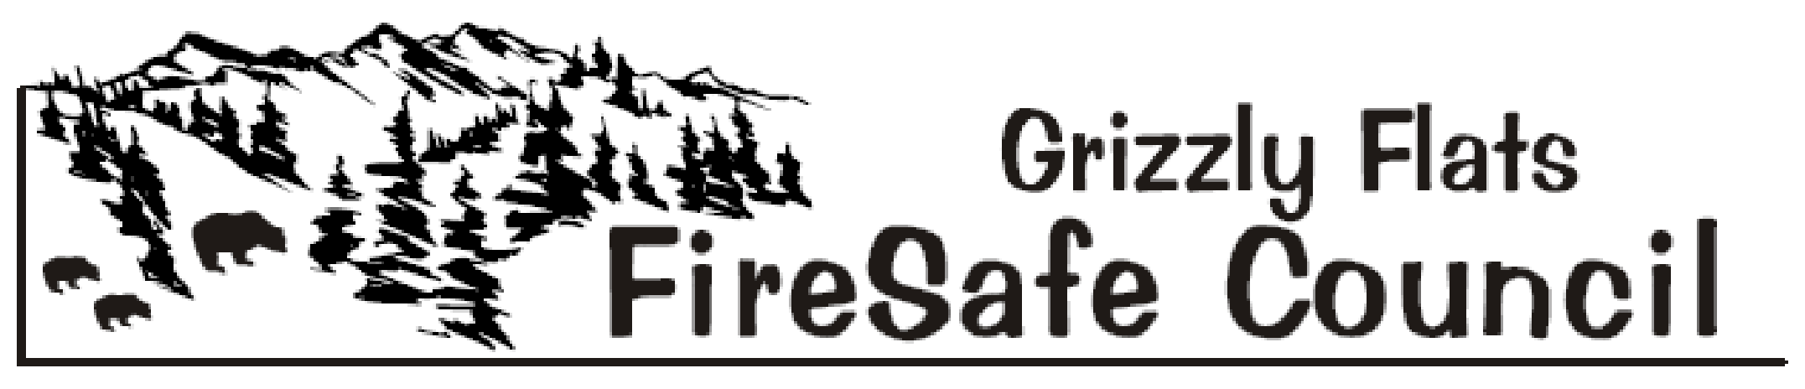
The Mission of the Grizzly Flats Fire Safe Council is to preserve Grizzly Flats’ natural and manmade resources by informing, educating and mobilizing all residents and landowners to make their homes, properties, neighborhoods and the community fire safe, and to provide area-wide cooperation, innovation and action in an effort to buffer the Grizzly Flats Fire Safe Council’s Sphere of Recognition from catastrophic wildfire

Agenda-May 1, 2021 9:30 a.m.- Telephone Meeting

1) Call to order

2) Flag Salute

3) Roll Call

4) Meeting Room Cleanup Volunteers & Timekeeper Volunteer

5) Approval of the May 1, 2021 Agenda

6) Approval of the April 10, 2021 Minutes

7) Treasurer’s Report- Robin Kelley

8) Public Comment
(Limited to 3 minutes - only for items not on the agenda)

9) Council Member Comments
(Limited to 3 minutes - only for items not on the agenda)

10) Agency Reports
- BOS Reports District 2 Supervisor. – George Turnboo

- Pioneer Fire Protection District –Chief Mark Matthews/Battalion Chief Mike
Stutts

C. Department of Transportation (DOT) – Brian Mullens

D. Grizzly Flats Community Service District - Kim Gustafson

E. Sheriff – John D’Agostini/Jack Kerruish

F. El Dorado County Fire Safe Council - Ernie Lory

G. California Highway Patrol – Public Information Officer - Andrew Brown

H. USFS - District Ranger Scot Rogers/Rick Hopson

I Amador El Dorado Unit Cal Fire - Public Information Officer- Diana Swart

J. Neighboring Fire Safe Councils
- Aukum/Fairplay
- Omo Ranch

11) Old Business
- Annual BBQ Fundraiser/Firewise-Day- Mark Almer/David Manske Discussion/Action item

- GFFSC Vacancies – Mark Almer/Ernie Lory- Discussion/Action Item

- AT&T Phone Issues- Mark Almer/Kelly Krohn/Phill Dayton Discussion/Action Item

- Capps Crossing Road Issues- Mark Almer Discussion/Action Item

- Community Service Award- Mark Almer Discussion/Action Item

12) New Business
A, Trestle Trail Clean-up-Mel/David/Manuel- Discussion/Action Item

B Elections Nominating Committee Formation- Mark Almer-
Discussion/Action Item

13) Committee Reports
- Public Outreach Coordinator – Deb Gregory

- Defensible Space - Steve Frasier/Robin Kelley

- Grants – Ernie Lory/Kelly Krohn/David Manske

- Public Education – Deb Gregory/Kelly Krohn/Logan Gregory

- Fundraising- Kelly Krohn/Robin Kelley/David Manske

14) Public Announcements

15) For the Good of the Order

16) Adjourn

Regular Local Fire Safe Councils and District Meetings:

Grizzly Flats FSC - 1st Saturdays 9:30 AM, Telephone Meeting (Temporary)
Pioneer Fire Protection District - 2nd Tuesdays 6 PM, Station 38
Aukum/Fairplay FSC- 3rd Wednesdays 7 PM - Pioneer Park Hall
Omo Ranch FSC - 4th Saturdays 9 AM – Indian Diggings School

