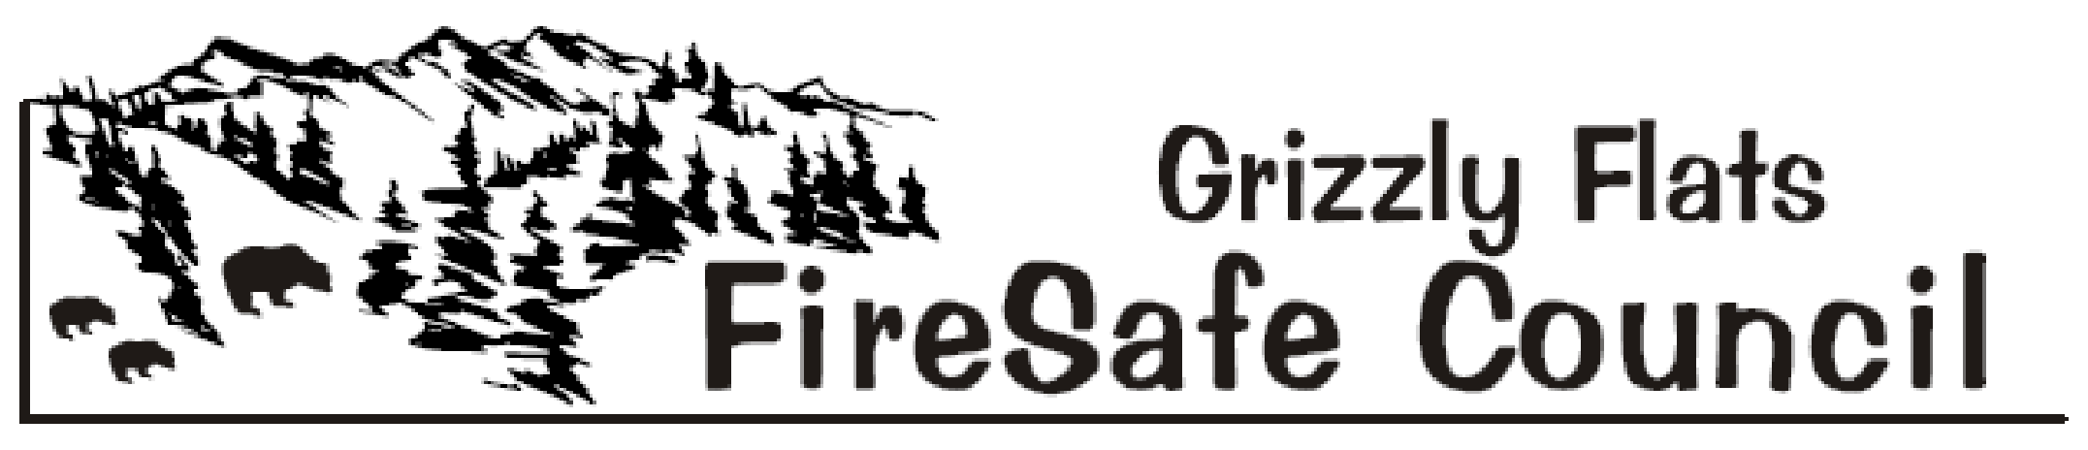
The Mission of the Grizzly Flats Fire Safe Council is to preserve Grizzly Flats’ natural and manmade resources by informing, educating and mobilizing all residents and landowners to make their homes, properties, neighborhoods and the community fire safe, and to provide area-wide cooperation, innovation and action in an effort to buffer the Grizzly Flats Fire Safe Council’s Sphere of Recognition from catastrophic wildfire

Agenda February 1, 2020 9:30 a.m. - Grizzly Flats Community Church

1) Call to order

2) Flag Salute

3) Roll Call

4) Meeting Room Cleanup Volunteers & Time Keeper Volunteers

5) Approval of the February 1, 2020 Agenda

6) Approval of the January 4, 2020 Minutes

7) Treasurer’s Report

8) Public Comment
(Limited to 3 minutes - only for items not on the agenda)

9) Council Member’s Comments
(Limited to 3 minutes - only for items not on the agenda)

SPECIAL PRESENTATION – Mapping of future GFFSC projects – Barry Callenberger

10) Agency Reports

- BOS Reports District 2 Supervisor. - Shiva Frentzen

B. Pioneer Fire Protection District – Chief Mark Matthews

C. Department of Transportation (DOT) – Brian Mullens

D. Grizzly Flats Community Service District - Kim Gustafson

E. Sheriff – John D’Agostini / Steve Wunschel

F. El Dorado County Fire Safe Council - Ernie Lory

G. California Highway Patrol – Public Information Officer - Andrew Brown

H. USFS - Captain Luke Birch

I. Neighboring Fire Safe Councils
- Pleasant Valley
- Aukum/Fairplay
- Omo Ranch

11) Old Business

- GFFSC Sphere of Recognition Map Change – Ad Hoc Committee – Discussion/Action Item

B. Four Corners Reader Board - Chief Matthews - Discussion/Action Item

C. Emergency Evacuation Route Signage – Chief Matthews/Don Spear/Steve Hupner – Discussion/ Action Item

D. Updates & Changes PPM & Bylaws – Mark Almer / Steve Hupner- Discussion Item

E. GFFSC Vacancies – Mark Almer – Discussion/Action Item

12) New Business

A. Updates & Changes Since Last Meeting – Mark Almer - Discussion Item

B. 2020 GFFSC Fundraiser BBQ - Mark Almer/David Manske – Discussion / Action Item

C. Sign up for 2020 committee positions – Mark Almer – Discussion/ Action

13) Committee Reports
- Public Outreach Coordinator – Deb Gregory

B. Defensible Space - Steve Frasier/Robin Kelley

C. Grants –Randy Rossi/Tracey Schaal/Kelly Krohn

D. Public Education – Deb Gregory

E. Standing Committee on Middle Fork - Randy Rossi / Robin Kelley

F. El Dorado County Vacant Parcel/Weed Abatement Ordinance - Ad Hoc

14) Public Announcements

15) For the Good of the Order

16) Adjourn

Regular Local Fire Safe Councils and District Meetings:

- Grizzly Flats FSC - 1st Saturdays 9:30 AM, Grizzly Flats Community Church
- Pioneer Fire Protection District - 2nd Tuesdays 6 PM, Station 38
- Pleasant Valley FSC - 2nd Thursdays 7 M - Pleasant Valley Community Hall
- Aukum/Fairplay FSC- 3rd Wednesdays 7 PM - Pioneer Park Hall
- Omo Ranch FSC - 4th Saturdays 9 AM -

